Organizational Legitimacy Measure:
The Case of Spanish Mutual Guarantee Societies

ABSTRACT

In order to understand an organizations' survival and growth, legitimacy plays a key role. Credibility, convenience and adjustment to social norms, values and beliefs make organizations more predictable, trustworthy and balanced. Institutional Theory identifies legitimacy as a critical success factor that all organizations must consider. In this sense, there is little empirical research in this field, essentially because of the hurdle of quantifying the concept of legitimacy. This study shows a step forward in the effort to establish a methodology for measuring organizational legitimacy. Our research has been developed over the Spanish Mutual Guarantee Societies. We have evaluated their legitimacy and ranked them according to his criterion. Furthermore, we have analyzed the relative importance of the different aspects of legitimacy in MGS and established a legitimacy profile for the sector. Results suggest that there is a widespread perception in society regarding internal and external organizations validation. The findings also show that it is possible to achieve high levels of legitimacy regardless of their source. In other words, two organizations may have the same level of legitimacy, where one of them has only pragmatic legitimacy and the other moral legitimacy.

KEY WORDS: Legitimacy, organizational legitimacy, Institutional Theory, Spanish Mutual Guarantee Societies, Analytic Hierarchy Process.

INTRODUCTION

In the attempt to understand an organization's survival and growth, legitimacy plays a key role. Organizations that show more credibility, convenience, and adjustment to social norms, values and beliefs are more predictable, trustworthy and balanced.

The development of specific strategic actions allows organizations to acquire, maintain and repair their legitimacy. These actions promote access to strategic resources that are needed by organizations to sustain their growth and survival (Zimmerman and Zeith, 2002). On the basis of this structure a number of issues could be considered, for example: what is the effect of legitimacy source on organizations' resource acquisition? Is legitimacy a continuous variable (Deeds et al., 1997) or, what kind of strategic action allows organizations to acquire more legitimacy? All of these are ideas that should be empirically proven and documented. In these matters the key concept to consider is organizational legitimacy, an abstract concept that presents great measurement difficulties (Bozeman, 1993; Suchman, 1995; Low and Johnston, 2008). This study takes a step forward in the effort to establish a methodology for measuring organizational legitimacy. We have studied legitimacy in Spanish Mutual Guarantee Societies (MGS) and ranked them. Furthermore, we have analyzed the relative importance of the different aspects of legitimacy in MGS and established a legitimacy profile for the sector.

This paper contributes in two fundamental ways to the current literature on legitimacy. Firstly, we establish a scale for measuring legitimacy, considering it as an aggregate of its different typologies. We include variables that have been contemplated theoretically but have never before been put into practice. Previous studies have concentrated on specific variables that are useful for building metrics on organizations belonging to the same sector, but can hardly be ported across sectors. We contribute a set of variables that can be used to measure legitimacy in any type of organization. Furthermore, previous research has generally measured only one aspect of legitimacy at a time. Our work establishes a global measure of legitimacy. Secondly, we use an analysis technique (Analytic Hierarchy Process) that has not been previously considered for legitimacy measurement. Through this technique we resolve some of the problems encountered by previous authors (small sample size, scarce quantitative data, and insufficient media information) and describe the relationships between the different typologies and parameters of legitimacy.

The structure of this paper commences with a review of previous literature in which we present the current state of scholarship on legitimacy and its implications. We then put forward a model that reflects the concept of legitimacy and discuss the methodology utilized in this study. Finally, we describe the results achieved and comment on the conclusions and implications derived from them, as well as future areas of research.

CONCEPTUAL FRAMEWORK

Legitimacy has been described as “a generalized perception or assumption that the actions of an entity are desirable, proper, or appropriate within some socially constructed system of norms, values, beliefs, and definitions” (Suchman, 1995). We have observed different procedures to quantify legitimacy in previous research, mainly quantitative content analysis (Deephouse, 1996; Ruef and Scott, 1998; Bansal and Clelland, 2004; Deephouse and Carter, 2005), interviews, and case study method (Rutherford y Buller, 2007; Low y Johnston, 2008). These studies have been based on specific indicators of use for building metrics on organizations that belong to the same sector, but can hardly be ported across sectors. Because of this, in order to operationalize legitimacy we have used the model proposed by Thomas (2005) which is characterized by indicators that can be applied to any type of organization.

Thomas (2005) identifies legitimacy as a multidimensional psychological construct made up of two dimensions: the referential locus, and the evaluative criteria or types of legitimacy. The model proposed by Thomas (2005) arises from studies by Harris (1994) as well as Dornbush and Scott (1975) concerning the referential locus dimension; along with Suchman (1995) with respect to the evaluative criteria. Thomas (2005) considers both dimensions jointly and relates them to create a new measurement scale. This author integrates the concepts used until now, connecting them in a joint framework.

The first dimension is made up of a combination of propriety and validity (Dornbush and Scott, 1975). Propriety refers to perceptions or belief that an action or policy is desirable, correct and appropriate, according to an individual's personal evaluative criteria. Validity refers to individuals’ beliefs that they are obligated to respond to social pressure to engage in actions or conform to policies and social norms, even in the absence of a personal sense of propriety. The second dimension consists of evaluative criteria or types of legitimacy that contribute, consciously or not, to individual perceptions of legitimacy. Suchman (1995) identifies three types of legitimacy: pragmatic, moral and cognitive.

FigurE 1. Legitimacy and its Dimensions
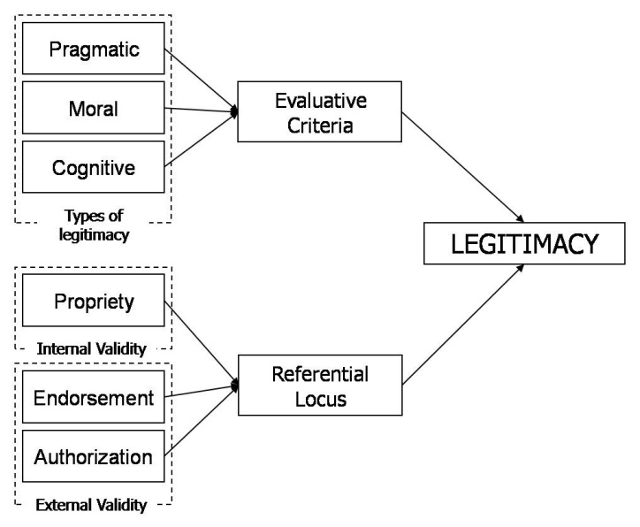
Source: Authors' own research based on Thomas (2005).

METHODOLOGY

Sample

We study Spanish Mutual Guarantee Societies (MGS), also known in the Spanish-speaking world as Reciprocal Guarantee Societies or SGR. MGS are organizations set up to facilitate SME's access to loan finance, negotiating acceptable financing conditions similar to those obtained by larger companies. The statistical universe is made up of 22 organizations, all currently active in Spain. The average age of the MGSs is 22 years, running from 28 years for the most experienced to 4 years for the least experienced. The average number of permanent employees was 23, with a range from 85 to 6. Average operating revenues were 3,094,314 euros, in a range of 18,997,000 to 264,598 euros.

Data collection

Certain authors such as Fombrun and Shanley (1990) or Llamas et al (2005) has measured organizational legitimacy (reputation) using different tools, from databases to surveys completed by managers with sector expertise in which they were asked to classify their companies according to different attributes. Human and Provan (2000), Rutherford and Buller (2007), or Low and Johnston (2008) have performed semi-structured interview analysis with organization founders and/or managers to measure legitimacy. This is a valid way of recognizing legitimacy since legitimacy arises from the adjustment of an organization's actions to its surrounding social values; founders and managers are necessarily highly cognizant of their organization's culture, customs, routines, and procedures.

Data collection was performed during February and March of 2009. A survey was designed and sent by e-mail to the risk managers and directors of the 22 organizations in the industry. In a time span of six weeks we received 17 completed surveys, or 72.72% of the population. The organizations that participated in the survey are among the most representative of the sector: SGR Comunitat Valenciana, Elkargi, and Iberaval. Participants in the study represent 88.7% of industry turnover. Considering this data, we consider the sample to be sufficiently representative of the universe, allowing the completion of the study and the establishment of conclusions.

Components and data analysis

In order to quantify legitimacy we adopt the components presented by Thomas (2005) in his model, which consists of two dimensions and six variables (figure 1). Juxtaposing the two dimensions creates a 3x3 matrix with nine components (table 1).

Table 1. Components of organizational legitimacy
 | Pragmatic | Moral | Cognitive
Propriety | LI01.You believe that all your organization's actions help it achieve its goals | LI04.You believe that all your organization's actions are the “right” thing to do, regardless of their pragmatic utility | LI07.You believe that your organization's actions help simplify the decision making process, accomplishing better, more rational decisions
Endorsement | LI02.Your colleagues believe that all your organization's actions help it achieve its goals | LI05.Your colleagues believe that all your organization's actions are the “right” thing to do, regardless of their pragmatic utility | LI08.Your colleagues believe that your organization's actions help simplify the decision making process, accomplishing better, more rational decisions
Authorization | LI03.Your boss/bosses believe that all your organization's actions help it achieve its goals | LI06.Your boss/bosses believe that all your organization's actions are the “right” thing to do, regardless of their pragmatic utility | LI09.Your boss/bosses believe that your organization's actions help simplify the decision making process, accomplishing better, more rational decisions
Source: Thomas (2005), p. 191.

Furthermore, Thomas (2005) simplifies this classification into a 2x2 matrix by reducing the number of relevant categories in each dimension. Thus, the author proposes to use a survey to elicit the extent of perceived legitimacy in each category using Likert-scaled responses. The results can then be plotted on a radar chart (figure 2) in such a way that the total area of the resulting quadrilateral polygon can be treated as an indicator of legitimacy.

FigurE 2. Legitimacy component scores, overall legitimacy and focal point 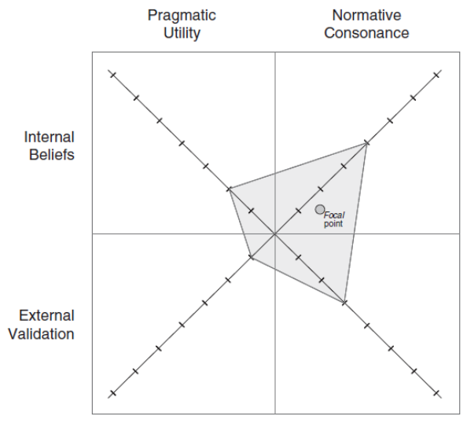
Source: Thomas (2005), p. 193.

Nevertheless, empirical study of legitimacy should include all variables in order to achieve maximum representativity. Taking this into account, we decided to make use of the more comprehensive model (3x3) with nine components (table 1). Reliability analysis of the scale surpassed accepted thresholds for newly developed scales, with a Cronbach alpha of 0.654 (Nunnally and Bernstein, 1994; Hair et al, 2006). The use of nine components instead of the four Thomas (2005) considers in his analysis makes it more problematic to calculate the total area of the resulting nonagon. Another issue to be overcome is the population's small size, 22 organizations, which makes any type of parametric analysis more difficult to perform. Given this context, we decided to analyze the components of legitimation with the Analytic Hierarchy Process (AHP) developed by Saaty (1977, 1980). This method allows us to organize and evaluate various alternatives in order to reach a decision goal following specific criteria. Furthermore, as it is a non-parametric methodology it can be used with small population sizes.

The model for measuring legitimacy is shown in figure 3. In regards to the weight given to each criteria with respect to the overall goal, we consider that the absence of research pointing to any of the criteria within the referential locus as more important than the others entails that they should be considered equally important with respect to legitimacy (33%). There is no theoretical or empirical literature that shows that propriety, endorsement, or authorization are more important components of legitimacy than the others. In order to establish the weights that indicate the relative importance of the components (L101...L109) with respect to their encompassing referential locus (propriety, endorsement and authorization) we used factor analysis.

FigurE 3. Model for Measuring Legitimacy
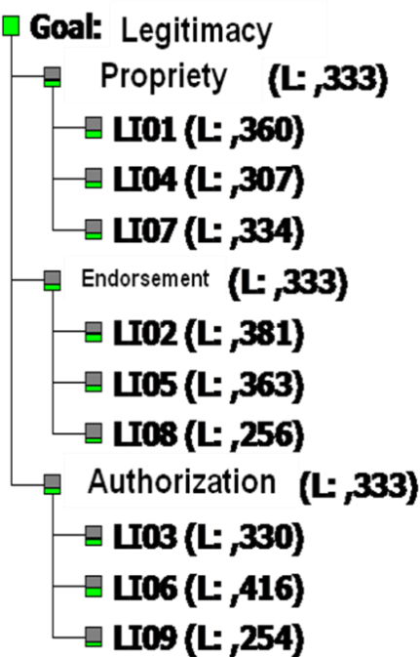
Source: Own research.

In our case the correlation matrix, Bartlett's test, and the KMO measure of sampling adequacy all showed that the components within each referential locus were correlated, fulfilling criteria for factor analysis (table 2). The different weights assigned to the components show relative importance with respect to their criteria.

TablE 2. Factor Matrix for Referential Locus Components
Component | Propriety Factor | Component | Endorsement Factor | Component | Authorization Factor
LI01 | 0,831 | LI02 | 0,939 | LI03 | 0,669
LI04 | 0,709 | LI05 | 0,896 | LI06 | 0,844
LI07 | 0,773 | LI08 | 0,631 | LI09 | 0,515

Finally, we determined preference for each alternative according to the criteria we had established. In other words, we stipulated the relative weight of the MGS with respect to each legitimacy component. For this we used a survey which inquired about the degree of agreement or disagreement with each component using a five-point Likert scale (1= strongly disagree, 5= strongly agree).

RESULTS

Table 3 collects the relative importance of each criteria and sub-criteria concerning MGS's legitimacy. It also shows the degree of legitimacy of each alternative, in this case of each MGS. The inconsistency index remains below 0.10, guaranteeing a valid model. Moreover, varying the degree of importance of the criteria and sub-criteria for legitimacy in the model does not cause large result variations. This fact confirms the robustness of the model and the results.

TablE 3. Component and Legitimacy Results
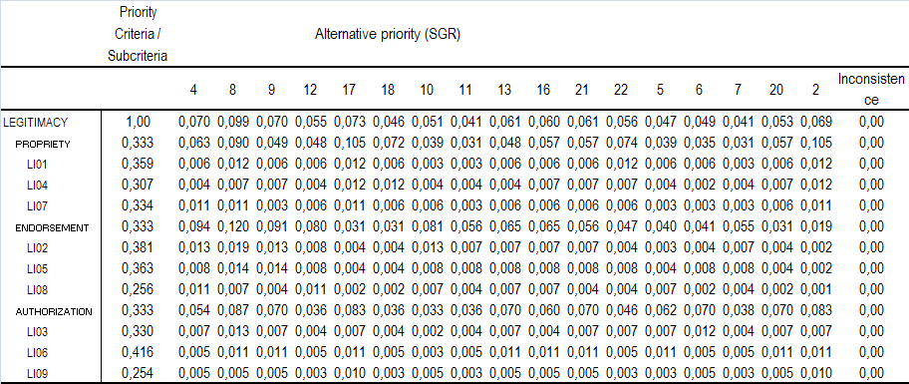

The results in the LEGITIMACY row show the different scores for legitimacy in MGS. This benchmark classifies MGS according to the degree of propriety, endorsement, and authorization of their activities. Considering that propriety, endorsement, and authorization are equally weighted components of legitimacy, the MGSs 08, 17, 04, 09, and 02 achieve the highest levels of legitimacy. By ranking the LEGITIMACY results, we can display the MGS on a continuous line according to their level of legitimacy (figure 4). In view of these results we observe greatly varying levels of legitimacy, with a maximum dispersion of legitimacy results among MGS of over 55% in the most extreme cases (maximum dispersion 58%).

FigurE 4. Ranking of MGSs According to Legitimacy Levels
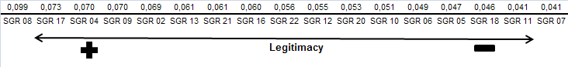

The rows PROPRIETY, ENDORSEMENT, and AUTHORIZATION show the degree of relative importance of these criteria in determining the legitimacy level of each MGS. In order to observe the existing result differences with respect to the relative importance of PROPRIETY, ENDORSEMENT, and AUTHORIZATION on legitimacy levels, we performed an analysis of variance (ANOVA). With this analysis we verified whether the values obtained by MGSs in the different components of legitimacy differed significantly across the three components. Results are shown in table 4.

TablE 4. ANOVA of Legitimacy Components
Components | Sig.
PROPRIETY | 0,024
ENDORSEMENT | 0,003
AUTHORIZATION | 0,044
P<0,05 is 95% significant - Factor: LEGITIMACY

Analysis of variance within PROPRIETY, ENDORSEMENT, and AUTHORIZATION proves, with significance levels below 0.05, that there are different behavior patterns among MGS. By pointing to the different notions its members have on the propriety, endorsement, and authorization of their activities, this data gives coherence to the disparity among the legitimacy results obtained by MGSs.

DISCUSSION, CONCLUSION, AND IMPLICATIONS

Institutional theory identifies legitimacy as a critical success factor that must be taken into account by all organizations (Suchman, 1995; Hunt and Aldrich, 1996; Zimmerman and Zeitz, 2002). Nevertheless, there is little empirical research on the subject. This might be caused by one of the most recurring problems surrounding legitimacy, its measurement (Bozeman, 1993; Suchman, 1995; Deephouse, 1996).

Our study has implemented a system of legitimacy components proposed by Thomas (2005) and has empirically proven the validity of a model that facilitates legitimacy measurement across all types of organizations, within the same or across different sectors (objective 1). Moreover, we have classified MGSs according to their degree of legitimacy, taking into account all its dimensions (objective 2). Nonwithstanding, although this methodology may be used to measure legitimacy in organizations across different sectors, this comparison should be performed with care.

The results of this investigation have also permitted to build a legitimacy profile of MGSs (objective 3). We have noted that there is not a common widespread perception concerning the propriety, endorsement, and authorization dimensions. In regards to propriety the results have shown that not all individuals, groups, and managers of MGSs view the actions of their organizations as desirable, proper, and appropriate. Furthermore, the individuals, groups, and managers of MGSs consider that the activities of their organizations lack sufficient endorsement and authorization from those with decision-making power.

Despite the results we have achieved and the usefulness of their implications, this study has limitations that suggest future areas of research. Firstly, the data used in this study comes exclusively from the replies given by organization members. The nature of the interview implies that founders/senior managers will answer affirmatively (Luque, 2000), contributing to a skewed vision of this characteristic, which should also be examined through the opinions of other stakeholders (Hybels, 1995; Vidaver-Cohen, 2007). Therefore, the results must be interpreted with caution. Future research might attempt to answer questions such as which dimension is more important in shaping legitimacy.

Another limitation of our research has been sample size. The sample of this study consisted of 17 MGS, 72.72% of the universe size, representing 88.7% of industry turnover, and a sampling error of 10.41%. This is an accepted percentage in business analysis studies (Luque, 2000), although it does not allow for generalization to the entire business market. For future research we suggest to increase the analysis' sample size, adding companies from the rest of the financial sector. Reputable indexes such as the FTSE4 Good Index might be used.

Finally, in future studies it would be interesting to relate the legitimacy scores we have obtained with a results variable, evaluating the hypotheses that establish a link between business legitimacy and survival and growth capabilities. This type of analysis would allow us not only to evaluate the impact of legitimacy on business, but also to develop legitimacy development strategies according to individual business circumstances (Oliver, 1999).

REFERENCES

Bansal, P; Clelland, I. (2004): “Talking trash: legitimacy, impression management, and unsystematic risk in the context of the natural environment”, Academy of Management Journal. Vol. 47, No. 1, pp. 93–103.
Bozeman, B. (1993): “Understanding the roots of publicness”, en B. Sutton (Ed). The legitimate corporation. pp. 63-81. Cambridge, MA: Blackwell.
Deeds, D. L.; Mang, P. Y.; Frandsen, M. (1997): “The quest for legitimacy: A study of biotechnology IPO's”. Congreso Anual de la Academy of Management, Boston.
Deephouse, D. L. (1996). “Does isomorphism legitimate?”, Academy of Management Journal, Vol. 39, No.4. pp. 1024-1039.
Deephouse, D. L; Carter, S. M. (2005). “An Examination of Differences Between Organizational Legitimacy and Organizational Reputation”, Journal of Management Studies, Vol. 42, No. 2, pp. 329-360
Déniz Déniz, M. and García Cabrera, A. (2011), “El isomorfismo mimético y las ventajas de localización como determinantes de la elección del modo de entrada”, Revista Europea de Dirección y Economía de la Empresa, Vol. 20 No. 1, pp. 105-122
Diez-Martin, F., Blanco-González, A. and Prado-Román, C. (2010), “Legitimidad como factor clave del éxito organizativo”, Investigaciones Europeas de Dirección y Economía de la Empresa, Vol. 16 No. 3, pp. 127-143.
Diez-Martin, F., Blanco-González, A. and Prado-Román, C. (2010), “Measuring organizational legitimacy: the case of Mutual Guarantee Societies”, Cuadernos de Economía y Dirección de Empresas, No. 43, pp. 115-143.
Dornbush, S.M.; Scott, W.R. (1975): Evaluation and the Exercise of Authority. San Francisco: Jossey-Bass.
Fombrun, C; Shanley, M. (1990): “What’s in a Name? Reputation Building and Corporate Strategy”, Academy of Management Journal, Vol. 33, No. 2, pp. 233-258.
Hair, J.F.; Black, W.C.; Balbin, B.; Anderson, R.E.; Tatham, R.L. (2006): Multivariate data analysis, 6ª ed. Upper Saddle River, NJ; Pearson Prentice Hall.
Harris, S.G. (1994): “Organizational culture and individual sensemaking: a schema-based perspective”, Organization Science, Vol. 5, No. 3, pp. 309–321.
Human, S. E; Provan, K. G. (2000): “Legitimacy building in the evolution of small firm mutilateral networks: a comparative study of success and demise”, Administrative Science Quarterly, Vol. 45, No. 2, pp. 327-365
Hunt, C. S.; Aldrich, H. E. (1996): “Why even Rodney Dangerfield has a home page: Legitimizing the world wide web as a medium for commercial endeavours”, Congreso Anual de la Academy of Management, Cincinnati, OH.
Hybels, R. (1995):” On legitimacy, legitimation, and organizations: A critical review and integrative theoretical model”, Academy of Management Journal, Special Issue: Best Papers Proceedings, pp. 241 - 245.
Llamas Sánchez, R.; García Morales, V. J.; López Martín, F. (2005): “Un análisis institucional de la implantación de la agenda local 21 por los ayuntamientos españoles”, Revista Europea de Dirección y Economía de la Empresa. Vol. 14, No. 3, pp. 9-40.
Low, B; Johnston, W. (2008): “Securing and managing an organization's network legitimacy: The case of Motorola China Industrial Marketing Management”, Industrial Marketing Management, Vol. 37, No. 7, pp. 873-879.
Luque, T. (2000): Técnicas de análisis de datos en investigación de mercados. Madrid, Pirámide.
Nunnally, J.; Bernstein, I.H. (1994): Psychometric Theory. 3ª ed. New York: McGraw-Hill
Oliver, C. (1999): “Strategic responses to institutional processes”, Academy of Management Review, Vol. 16, No. 1, pp 145-179.
Ruef, M.; Scott, R. (1998): “A multidimensional model of organizational legitimacy: Hospital survival in changing institutional environments”, Administrative Science Quarterly; Vol. 43, No. 4, pp. 877-904
Rutherford, M.W., Buller, P. F. (2007): “Searching for the legitimacy threshold”, Journal of Management Inquiry; Vol. 16, No. 1, pp. 78-92.
Saaty, T.L. (1977): “A Scaling Method for Priorities in Hierarchical Structures”, Journal of Mathematical Psychology, Vol. 15, No. 3, pp. 234-281.
Saaty, T.L. (1980): The Analytic Hierarchy Process. McGraw Hill, New York. Reprinted in 1996. Pittsburgh, RWS Publications.
Suchman M. (1995): “Managing legitimacy: strategic and institutional approaches”, Academy of Management Review, Vol. 20, No. 3, pp. 571-610.
Thomas, T. E. (2005): “Are business students buying it? A theoretical framework for measuring attitudes toward the legitimacy of environmental sustainability”, Business Strategy and the Environment, Vol. 14, No. 3, pp. 186-197.
Vidaver-Cohen, D. (2007): “Reputation Beyond the Rankings: A Conceptual Framework for Business School Research”, Corporate Reputation Review, Vol. 10, No. 4, pp. 278–304
Zimmerman, M.; Zeitz, G. (2002): “Beyond survival: achieving new venture growth by building legitimacy”, Academy of Management Review, Vol. 27, No. 3, pp. 414-31.
Zucker, L.G. (1987), “Institutional theories of organization”, Annual Review of Sociology, Vol. 13, pp. 443-464.

SABI Data base (2008)

